
ANTONINE UNIVERSITY

Faculty of Engineering
Department of Technology in Computer Science

Subject

Computer Science Internship Report

Carried out by | Joseph Abou Jaoude, 202211255  Technology in Computer Science Student
Host Company | Statometry

ACKNOWLEDGMENTS
I would like to thank Antonine University, the Faculty of Engineering, and the Department of Technology in Computer Science for providing the opportunity to complete this internship.

I would also like to thank my academic advisor for their guidance and support throughout the internship period.

My sincere appreciation goes to Statometry for welcoming me as an intern and for trusting me with meaningful, real-world responsibilities in data science and survey analytics. I would especially like to thank my supervisor, Mr. Joe Estephan, for his continuous support, explanations, and feedback, which helped me understand both the technical and business context of the project.

Finally, I would like to thank my family and friends for their encouragement and support during this experience.

ABSTRACT
This report presents the internship carried out at Statometry between May 30, 2025 and August 8, 2025. The main objective of the internship was to design and implement a survey data analysis platform that enables market researchers and analysts to process SPSS survey files, reshape data for analysis, and run advanced statistical techniques such as correspondence analysis and regression without writing code.

The internship started with a Streamlit-based prototype that integrated survey file uploads, data preview, pivoting from wide to long format, automated regression, and initial correspondence analysis. As the requirements grew, the architecture evolved into a Flask-based backend exposing REST APIs, with a separate frontend for greater flexibility, better UI/UX, and improved scalability.

Throughout the internship, I worked on file handling, pivoting logic, Excel questionnaire metadata parsing, awareness metrics, demographic filtering, and automated export of analysis results to Excel. The internship allowed me to apply theoretical knowledge in Python, data manipulation, and statistics to a real-world project, while also gaining experience in software architecture, remote collaboration, and iterative development.

The platform produced during the internship constitutes a solid foundation for future enhancements and can be used as an internal tool at Statometry to accelerate survey analysis workflows.

TABLE OF CONTENTS
Contents
ACKNOWLEDGMENTS 2
ABSTRACT 3
TABLE OF CONTENTS 4
INTRODUCTION 5
CHAPTER 1 : COMPANY PRESENTATION 6
1. INTRODUCTION 6
2. HOST ORGANIZATION 6
3. INTERNAL REGULATIONS 6
4. ROLE WITHIN TEAM 7
5. SUMMARY 7
CHAPTER 2 : OBSERVATIONS AND TASKS ACCOMPLISHED 8
1. INTRODUCTION 8
2. DATA PROCESSING AND FILE HANDLING 8
3. STATISTICAL ANALYSIS MODULES 11
4. QUESTIONNAIRE METADATA AND AWARENESS LOGIC 13
5. SYSTEM ARCHITECTURE AND USER INTERFACE EVOLUTION 14
6. SUMMARY 16
CHAPITRE 3 : INTERNSHIP EVALUATION 17
1. INTRODUCTION 17
2. EVALUATION OF THE WORK 17
3. CHALLENGES ENCOUNTERED 17
4. EVALUATION OF THE WORKING ENVIRONMENT 18
5. EVALUATION OF APPLIED KNOWLEDGE 18
6. SUMMARY 18
CONCLUSION 19
TABLE OF IMAGES 20
LIST OF ABBREVIATIONS 21
APPENDIX A – STREAMLIT VERSION SCREENSHOTS 22
APPENDIX B – FLASK VERSION SCREENSHOTS 33

INTRODUCTION
Internships play an essential role in bridging the gap between academic learning and professional practice. As part of the Technology in Computer Science program at Antonine University, I completed a mandatory internship at Statometry, a data intelligence and marketing research consultancy based in Beirut.

The objective of this internship was to participate in the development of a data science–oriented web application for survey analysis. The application was intended to help analysts work with SPSS survey data, reshape it into analysis-ready formats, compute awareness metrics, and run correspondence analysis and regression models through an intuitive interface.

This report presents the context of the host company, details the tasks and responsibilities carried out, evaluates the skills acquired and challenges encountered, and reflects on the contribution of this internship to my academic and professional development.

CHAPTER 1 : COMPANY PRESENTATION

1. INTRODUCTION
This chapter presents the host company Statometry, its activities, internal regulations, and the role assigned to me as an intern within the team.

2. HOST ORGANIZATION
Statometry is an independent, agile, boutique consultancy and marketing services firm founded in August 2017 and based in Beirut Souks, Lebanon. The company specializes in data intelligence, research analytics, and statistical modeling for clients across the Arab region. Statometry supports organizations in making data-driven decisions by designing surveys, analyzing complex datasets, and delivering actionable insights.

The company operates mainly in the fields of market research, brand tracking, customer satisfaction, and consumer behavior analysis. Its services include survey design, sampling, data collection coordination, statistical modeling, and analytical reporting.

Within Statometry, my internship was attached to a data analytics and tools development activity. The project I worked on aimed to strengthen the internal survey analysis capabilities by building a reusable, configurable software platform for processing survey data and running advanced analyses.

3. INTERNAL REGULATIONS
During the internship, the internal regulations at Statometry were mainly centered on task completion, confidentiality, communication, and reporting:

- Working hours were flexible. There was no fixed daily schedule, but weekly tasks were assigned and expected to be progressed within the agreed timeframe.
- Confidentiality was essential. The project I worked on, including its code and design, was an internal tool owned by Statometry and was not to be shared outside the company.
- Communication with my supervisor took place primarily via email and WhatsApp, which allowed for quick feedback, clarifications, and sharing of files or screenshots.
- A weekly reporting structure was followed. At the end of each week, I prepared an update summarizing the tasks assigned, progress achieved, issues encountered, and next steps.

These regulations provided enough flexibility to work remotely while ensuring that the project remained aligned with the company’s standards and confidentiality requirements.

4. ROLE WITHIN TEAM
My role in the team was that of a data science and tools development intern. I reported directly to my supervisor, Mr. Joe Estephan, who was responsible for specifying requirements, validating technical choices, and reviewing the progress of the platform.

We interacted on a weekly basis through online meetings, emails, and WhatsApp messages. Tasks were assigned in weekly batches and often involved both exploratory work and implementation. While I worked independently most of the time, my supervisor provided crucial guidance on how the existing survey analysis processes functioned and how the tool should support real client projects.

The expected deliverables were incremental: each week, specific features were planned, such as improving pivoting logic, adding a new type of analysis, or adjusting the questionnaire metadata handling. When tasks were larger than expected, the deadlines were adapted, and we split work into smaller, achievable milestones.

5. SUMMARY
Statometry provided a professional, flexible, and supportive environment for this internship. The company operates in data-driven marketing and research analytics, which aligned well with the project objectives. Clear expectations on confidentiality, communication, and weekly reporting allowed me to focus on building a robust survey analysis platform while regularly aligning with my supervisor.

CHAPTER 2 : OBSERVATIONS AND TASKS ACCOMPLISHED

1. INTRODUCTION
This chapter describes the work carried out during the internship. The project evolved from a Streamlit-based prototype into a Flask-based backend, but the core objectives remained the same: to provide a practical tool for survey data processing, pivoting, analysis, and reporting. The tasks are grouped into four main categories: data processing and file handling, statistical analysis modules, questionnaire metadata and awareness logic, and system architecture and user interface evolution.

2. DATA PROCESSING AND FILE HANDLING
The first set of tasks focused on preparing the environment, handling different survey file formats, and implementing robust pivoting logic to reshape data from wide to long formats suitable for analysis.
- Environment and tool familiarization: I installed and configured the required Python libraries, practiced loading SPSS .sav files using pyreadstat, and explored Streamlit widgets for file upload, data preview, and interactive controls.
- File upload and display integration: I implemented upload support for .csv, .xlsx, .sav and .dta files, and added a data preview table with pagination to allow quick inspection of the raw survey data.
- Long pivot attempts and debugging: I developed initial transformation logic to convert wide survey data into a long format, but encountered mismatches in column group sizes. This required investigation into grouping rules and consistent naming patterns.
- Grouping fixes and dynamic pivoting: I eventually solved the pivoting issues by automatically grouping columns based on shared prefixes and equal counts, allowing each group to be pivoted separately. This made the tool robust to typical survey naming conventions.
- Export functionality: I implemented export options to download processed data as .csv and .sav, preserving labels and value mappings for SPSS use.

Figure 2.1 – Streamlit interface example (Screenshot 2025-11-30 175826.png)
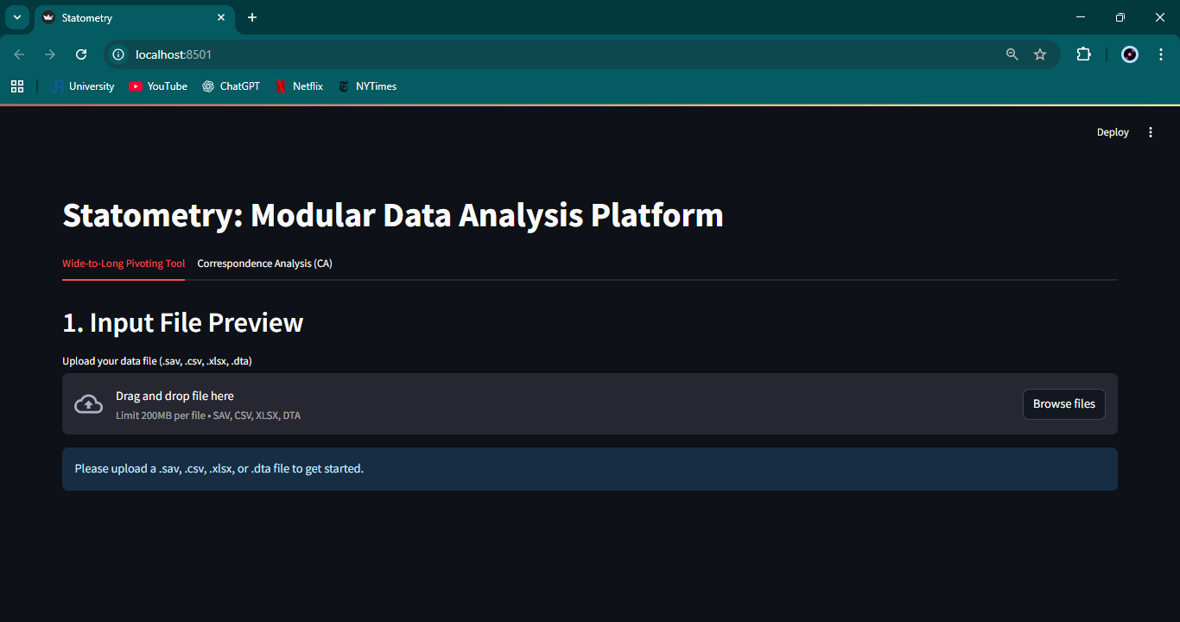
Figure 2.2 – Streamlit interface example (Screenshot 2025-11-30 175831.png)
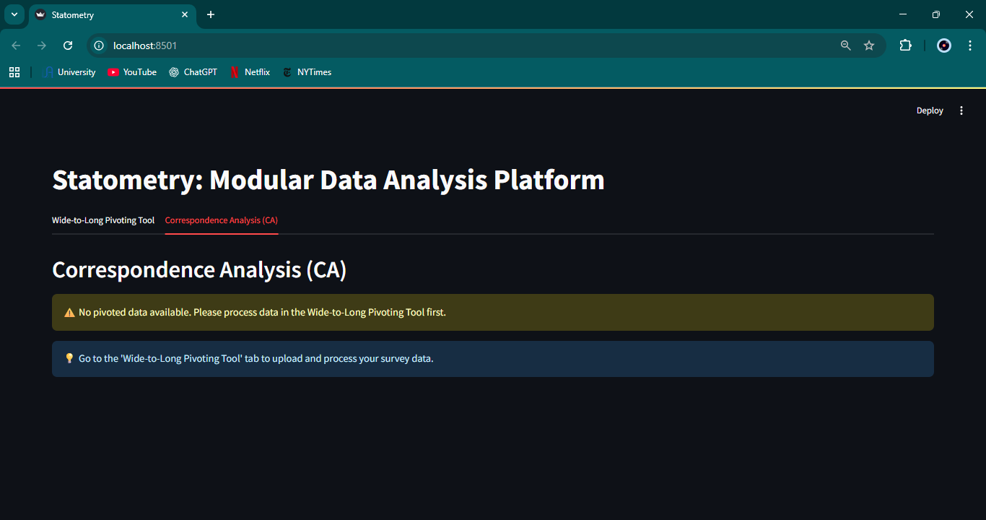
Figure 2.3 – Streamlit interface example (Screenshot 2025-11-30 175901.png)
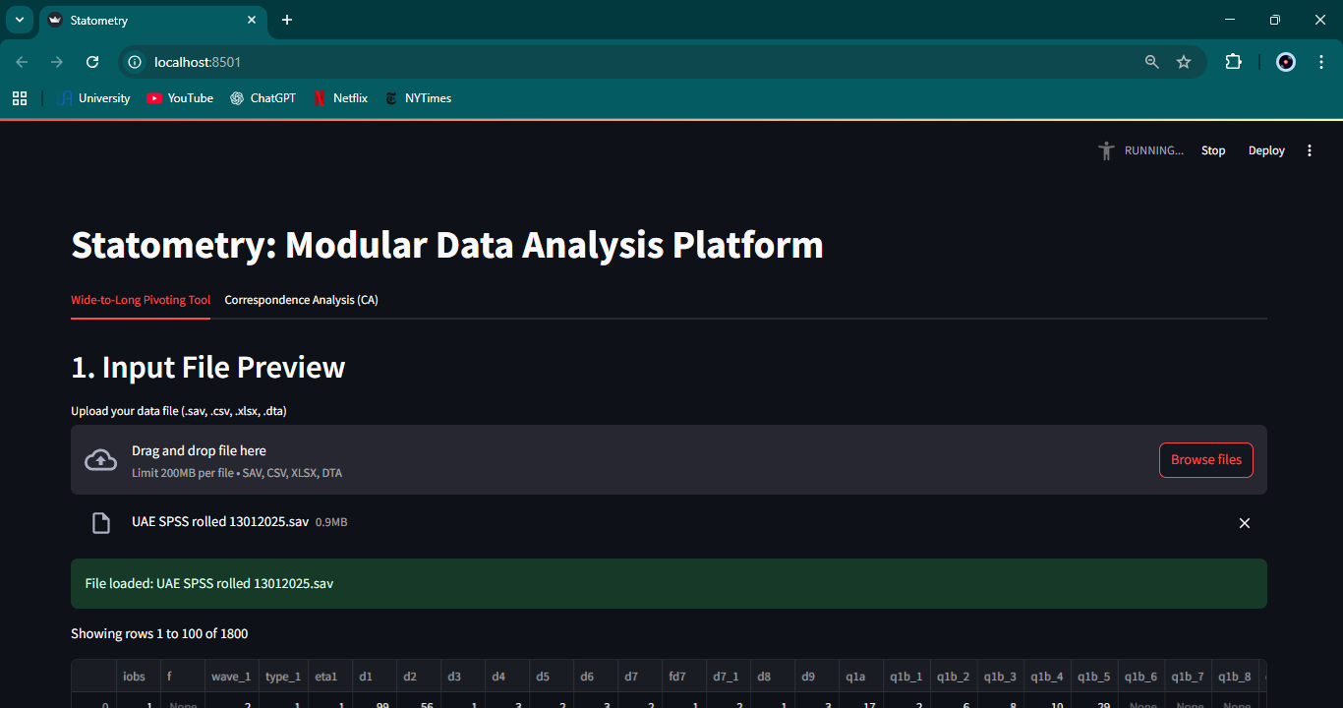

3. STATISTICAL ANALYSIS MODULES
Once the data processing pipeline was stable, I implemented automated statistical modules to support key driver analysis and correspondence analysis for survey data.
- Correspondence analysis on survey cohorts: I set up an automated pipeline to run correspondence analysis (CA) on selected survey variables. The goal was to visualize relationships between brands, attributes, and respondent segments in low-dimensional space.
- Linear and logistic regression for key driver analysis: I developed an engine that runs regression models based on user selections of dependent and independent variables. The output included coefficients, significance levels, and model diagnostics formatted for non-technical users.
- Refinement of CA support: I extended the CA module to handle singular groups and integrated it with the pivoted data so that both isolated questions and grouped variables could be analyzed together.

Figure 2.4 – Streamlit analysis view (Screenshot 2025-11-30 175913.png)
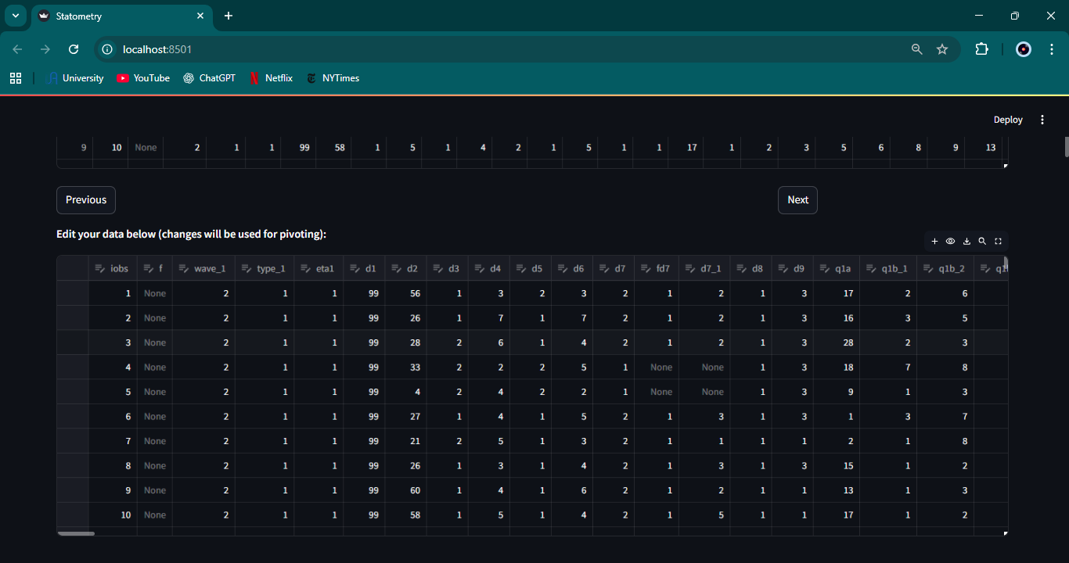
Figure 2.5 – Streamlit analysis view (Screenshot 2025-11-30 175924.png)
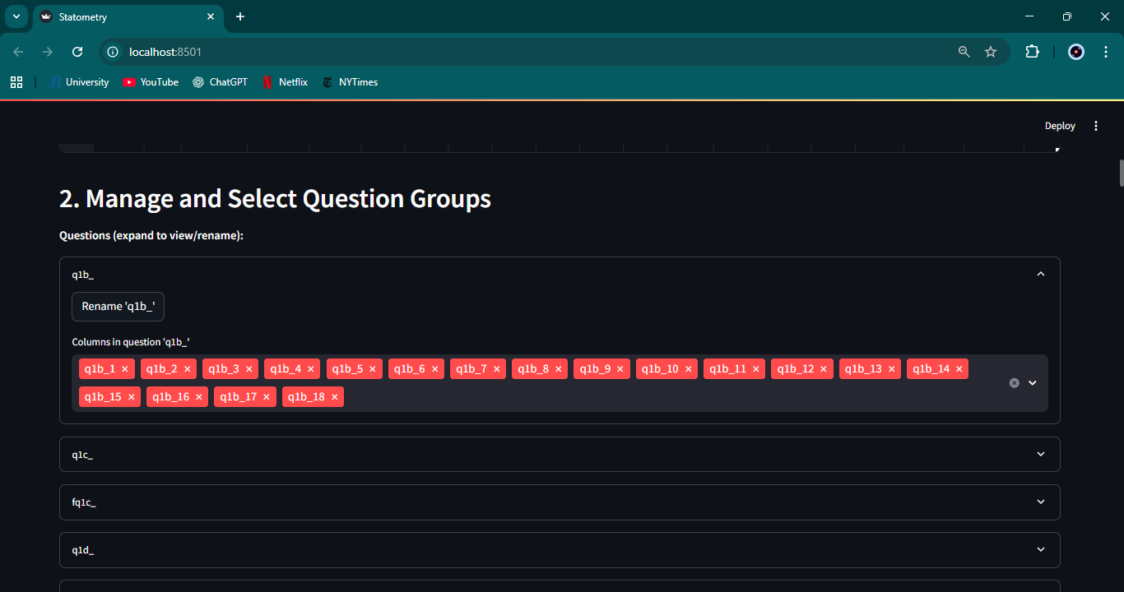
Figure 2.6 – Streamlit analysis view (Screenshot 2025-11-30 175931.png)
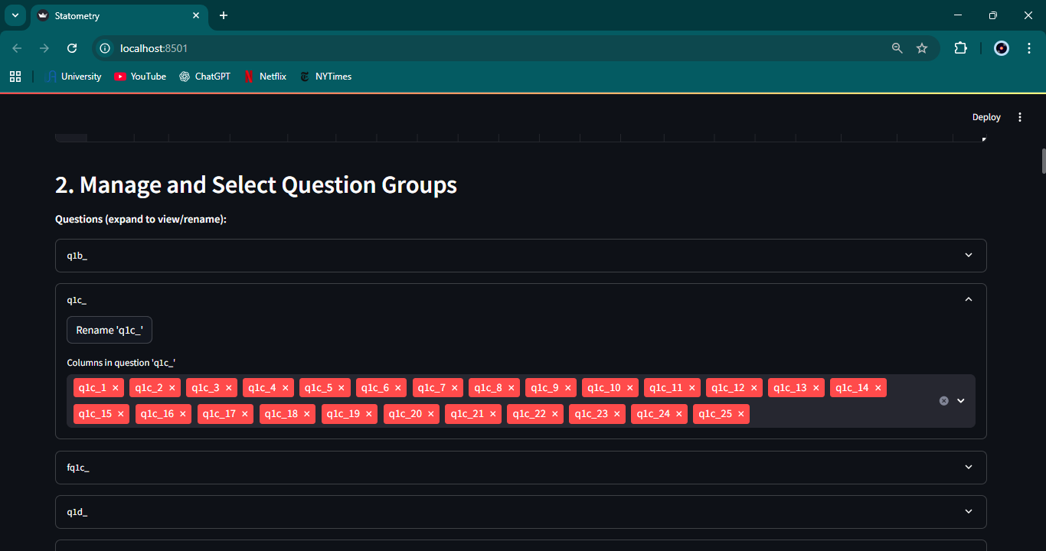

4. QUESTIONNAIRE METADATA AND AWARENESS LOGIC
To connect survey variables with questionnaire structure, I implemented metadata parsing and awareness calculation logic driven by Excel files.
- DOCX questionnaire parsing prototype: Initially, I experimented with parsing .docx questionnaires using python-docx, extracting question codes, texts, and types from unstructured paragraphs.
- Migration to Excel-based metadata: Because the .docx structure was not reliable, I replaced it with a structured .xlsx format. Rows in the Excel file provided question codes, texts, types, options, and categories that could be parsed and displayed in the interface.
- Metadata mapping to pivoted variables: I implemented logic to link questionnaire metadata to pivoted variables so that each transformed column still carried its semantic meaning.
- Awareness extraction and total awareness calculation: I built a pipeline to identify awareness-related questions, classify responses (Top of Mind, Aided Awareness, Other Specify), and compute total awareness metrics. I also added deduplication logic to ensure each respondent contributed at most once per brand.
- Excel export enhancements: I updated the export mechanism so that edits to question categories and mappings in the UI were reflected back into the exported Excel file.

5. SYSTEM ARCHITECTURE AND USER INTERFACE EVOLUTION
As the project grew, the initial Streamlit prototype was migrated to a cleaner architecture based on a Flask backend and a separate frontend, with improved terminology and user guidance.
- GUI refinement and terminology simplification: I adjusted labels, tooltips, and section names to make the interface more understandable to non-technical users. For instance, I replaced the term 'group' with 'question' when referring to sets of columns created from the same questionnaire item.
- Migration from Streamlit to Flask: I refactored the application into a modular Flask backend. Core features such as file uploads, pivoting, metadata parsing, and CA were exposed through REST endpoints, and session management was implemented using a custom session manager.
- Demographic filtering integration: I added demographic filters to the CA workflow, allowing the user to focus on specific respondent subsets (for example, particular age groups or genders). Filtering was applied at the raw data stage before pivoting, and the rest of the CA pipeline reused the existing logic on the filtered dataset.

Figure 2.7 – Flask-based interface example (Screenshot 2025-11-30 180610.png)
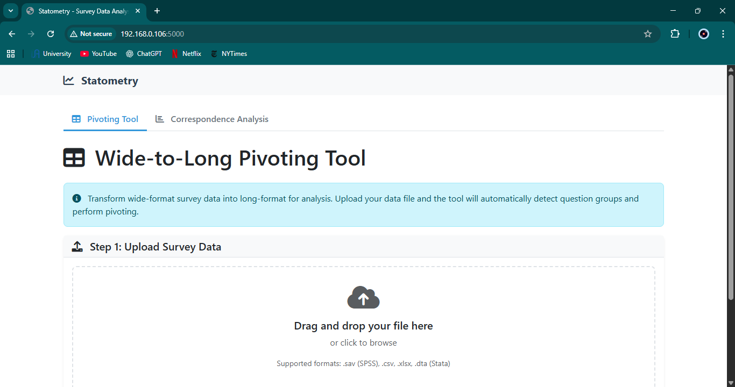
Figure 2.8 – Flask-based interface example (Screenshot 2025-11-30 180615.png)
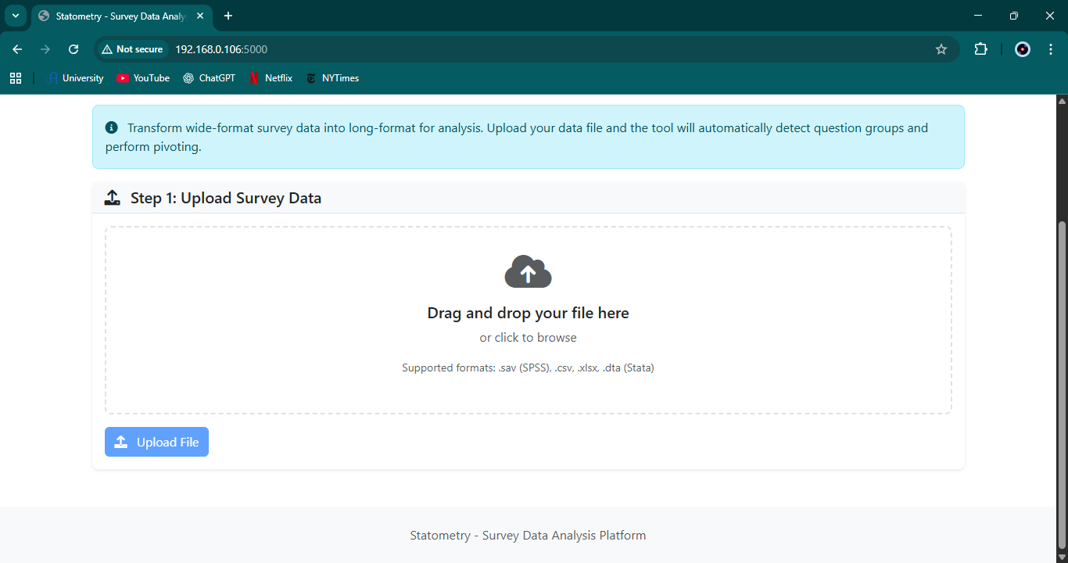
Figure 2.9 – Flask-based interface example (Screenshot 2025-11-30 180624.png)
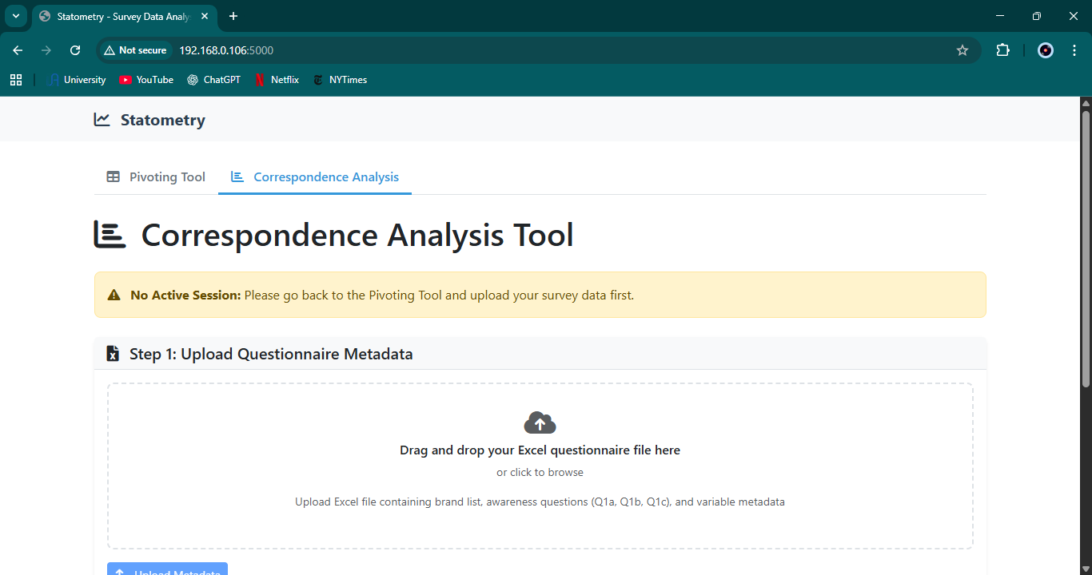
Figure 2.10 – Flask-based interface example (Screenshot 2025-11-30 180628.png)
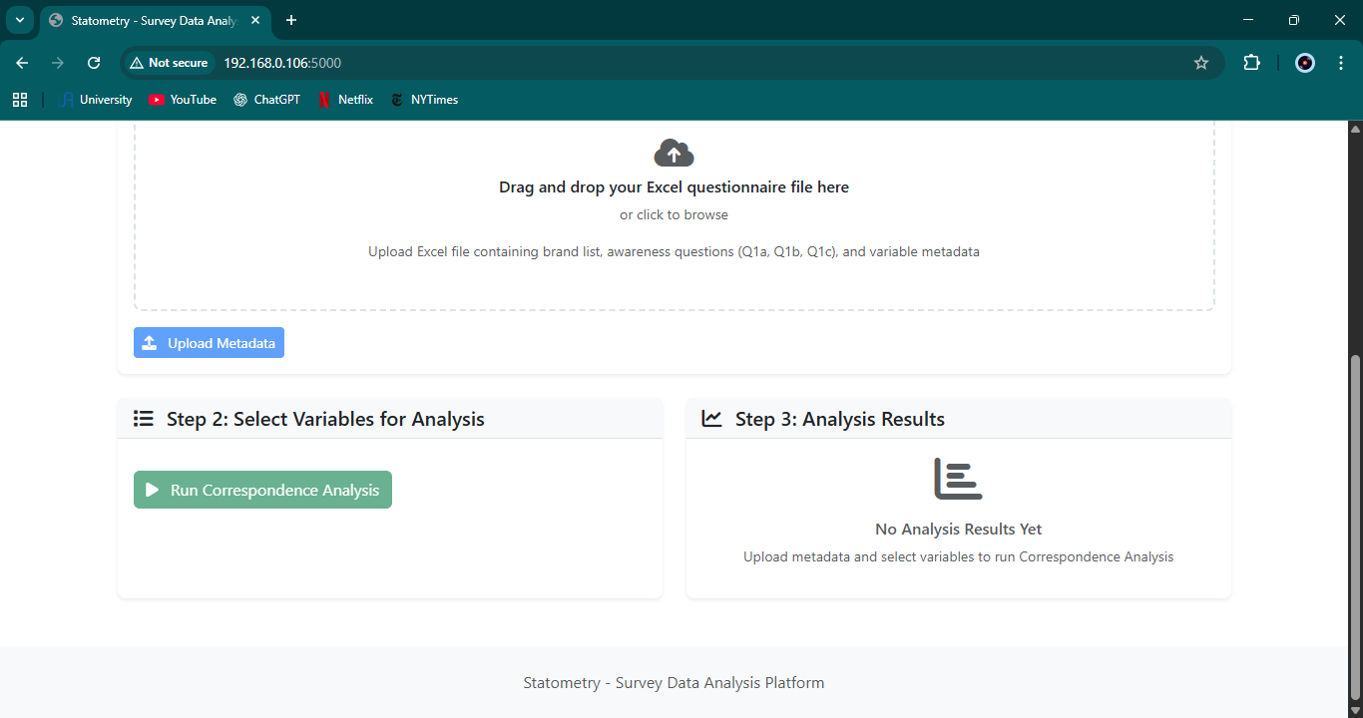

6. SUMMARY
The work carried out during the internship covered the full lifecycle of a data analysis platform: from prototype development in Streamlit, through rigorous pivoting and metadata handling, to a more scalable Flask-based architecture. The result is a practical internal tool that supports survey data uploading, reshaping, analysis, and export for Statometry.

CHAPITRE 3 : INTERNSHIP EVALUATION

1. INTRODUCTION
This chapter evaluates the internship in terms of the work carried out, challenges encountered, the working environment, and the application of academic knowledge.

2. EVALUATION OF THE WORK
The planned objectives of building a survey data analysis tool were largely achieved. A functional prototype was first created in Streamlit, then evolved into a Flask-based application with a modular backend. Key functionalities such as file uploads, pivoting, awareness calculation, correspondence analysis, demographic filtering, and Excel export were implemented and tested on real or realistic survey data.

The work delivered added value to Statometry by providing an internal platform that accelerates repetitive survey analysis tasks and standardizes certain computations like awareness and CA. The modular design also leaves room for further improvements and integration with other tools.

3. CHALLENGES ENCOUNTERED
Several challenges arose during the internship:

- Handling different survey file formats and ensuring consistency between SPSS, CSV, and Excel sources.
- Designing robust pivoting logic that automatically groups columns and handles irregular naming conventions.
- Exporting to .sav format with preserved labels and value mappings, which required exploring pyreadstat behavior.
- Ensuring acceptable performance when processing large datasets in memory.
- Migrating from a monolithic Streamlit app to a Flask backend without losing existing features.
- Implementing demographic filtering in a way that fit naturally into the existing CA pipeline.

Each challenge required research, experimentation, and iterative refinement, which contributed significantly to my learning.

4. EVALUATION OF THE WORKING ENVIRONMENT
The working environment at Statometry was remote, flexible, and supportive. Weekly meetings with my supervisor allowed us to align on priorities, clarify requirements, and review progress. Communication via email and WhatsApp was efficient and responsive.

The flexibility in working hours made it possible to adapt the internship workload to academic and personal constraints, while the clear expectation of weekly deliverables kept the project moving steadily forward.

5. EVALUATION OF APPLIED KNOWLEDGE
The internship gave me the opportunity to apply and extend knowledge acquired during my studies:

- Programming in Python for data processing and backend development.
- Data manipulation using Pandas, including pivoting, filtering, and aggregation.
- Statistical concepts such as regression and correspondence analysis.
- Web application development, from Streamlit prototypes to Flask REST APIs.
- Software engineering skills such as modular design, session management, and export functions.

The gap between academic exercises and real-world data was clear: real survey data contains irregularities, large volumes, and evolving requirements. Working through these constraints helped me gain a more realistic view of data science practice.

6. SUMMARY
Overall, the internship was a positive and constructive experience. The work completed met the initial objectives, and the challenges encountered contributed to both technical and professional growth.

CONCLUSION
This internship at Statometry was an important step in my academic and professional journey. It gave me the opportunity to work on a real survey analysis platform, evolve a prototype into a more scalable architecture, and apply advanced statistical techniques in a practical context.

Beyond the technical skills gained in Python, data manipulation, and web development, the internship taught me how to manage tasks over time, communicate progress, and adapt to changing requirements. The experience confirmed my interest in data science and analytics, and provided a concrete example of how computing skills can support business decision-making.

In the future, the platform developed during this internship can be extended with additional analyses, improved visualizations, and closer integration with Statometry’s workflows. For me personally, the internship strengthened my confidence in tackling complex projects and prepared me for future roles in data and software development.

TABLE OF IMAGES
Figure 2.1 – Streamlit interface example
Figure 2.2 – Streamlit interface example
Figure 2.3 – Streamlit interface example
Figure 2.4 – Streamlit analysis view
Figure 2.5 – Streamlit analysis view
Figure 2.6 – Streamlit analysis view
Figure 2.7 – Flask-based interface example
Figure 2.8 – Flask-based interface example
Figure 2.9 – Flask-based interface example
Figure 2.10 – Flask-based interface example

LIST OF ABBREVIATIONS
API – Application Programming Interface
CA – Correspondence Analysis
CSV – Comma-Separated Values
GUI – Graphical User Interface
HTML – HyperText Markup Language
SPSS – Statistical Package for the Social Sciences
UI – User Interface
UX – User Experience
XLSX – Microsoft Excel Open XML Spreadsheet

APPENDIX A – STREAMLIT VERSION SCREENSHOTS
Figure A.1 – Streamlit screenshot (Screenshot 2025-11-30 175826.png)

Figure A.2 – Streamlit screenshot (Screenshot 2025-11-30 175831.png)

Figure A.3 – Streamlit screenshot (Screenshot 2025-11-30 175901.png)

Figure A.4 – Streamlit screenshot (Screenshot 2025-11-30 175913.png)

Figure A.5 – Streamlit screenshot (Screenshot 2025-11-30 175924.png)

Figure A.6 – Streamlit screenshot (Screenshot 2025-11-30 175931.png)

Figure A.7 – Streamlit screenshot (Screenshot 2025-11-30 175940.png)
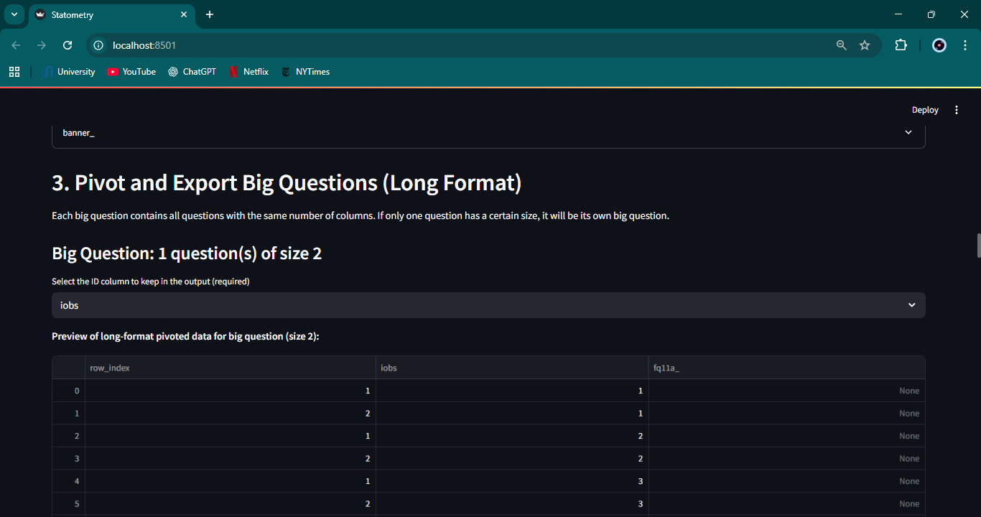
Figure A.8 – Streamlit screenshot (Screenshot 2025-11-30 175956.png)
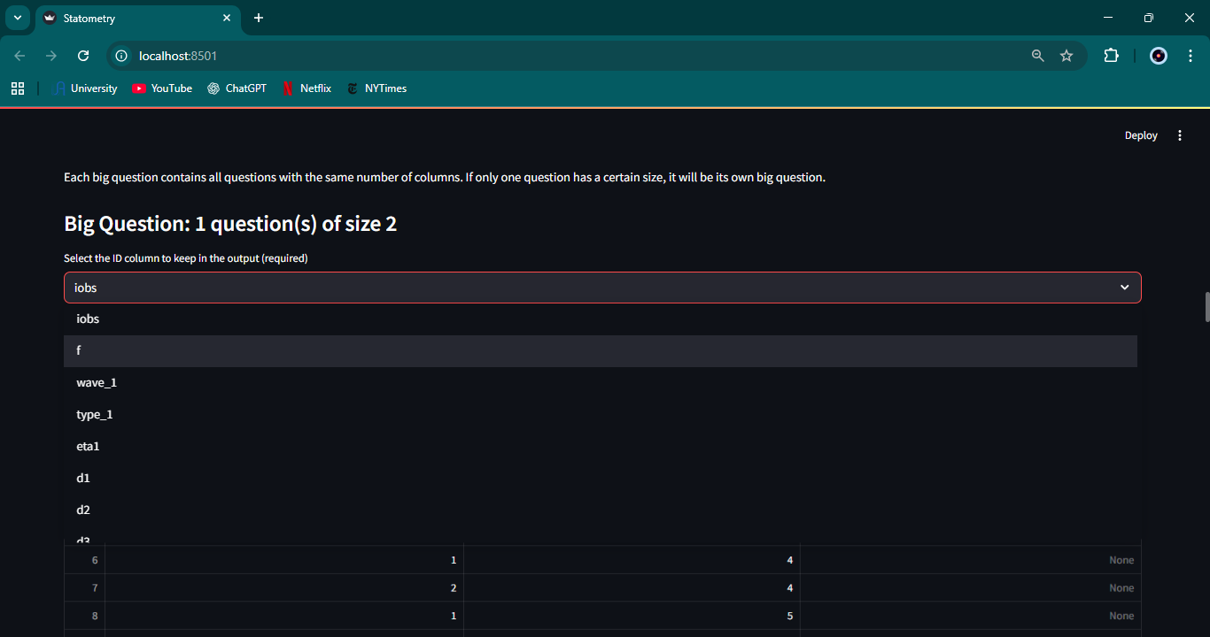
Figure A.9 – Streamlit screenshot (Screenshot 2025-11-30 180011.png)
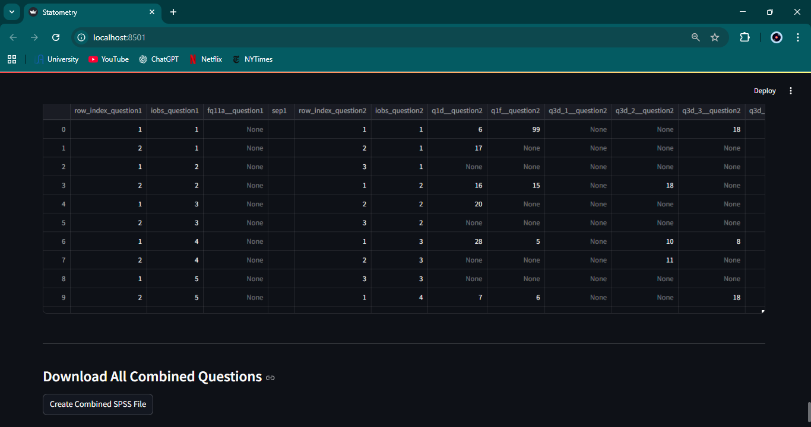
Figure A.10 – Streamlit screenshot (Screenshot 2025-11-30 180050.png)
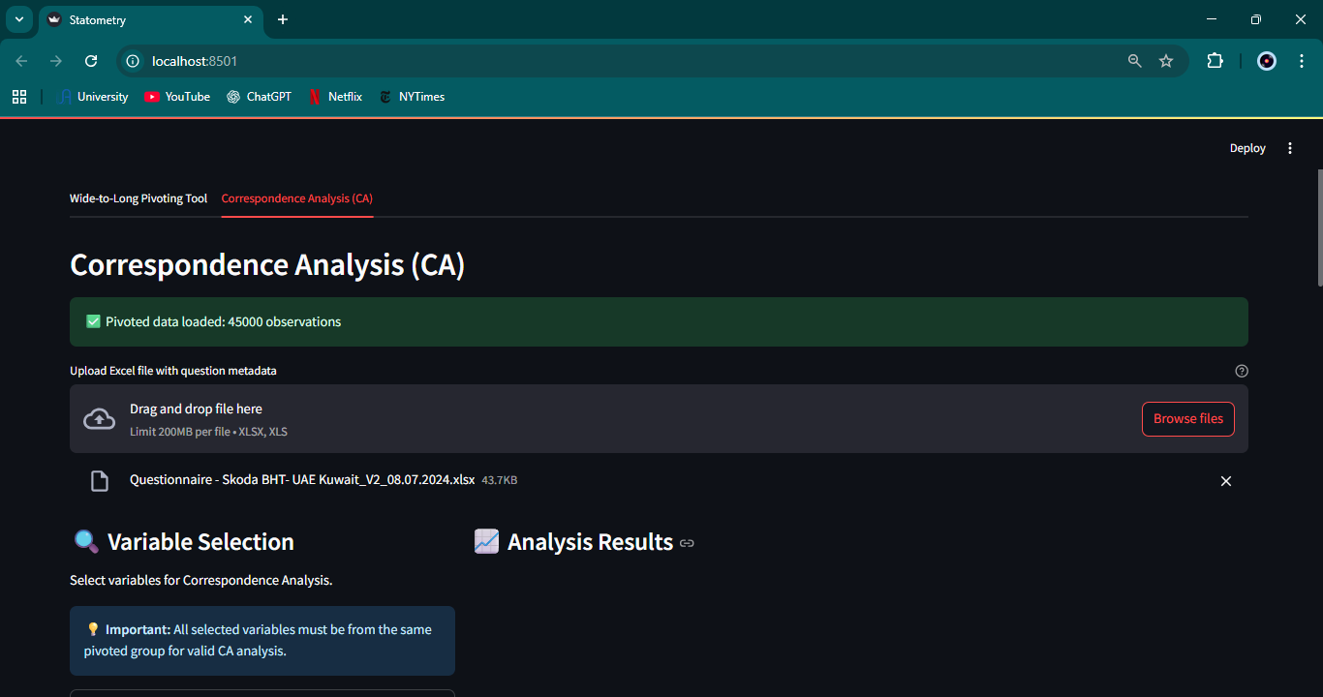
Figure A.11 – Streamlit screenshot (Screenshot 2025-11-30 180056.png)
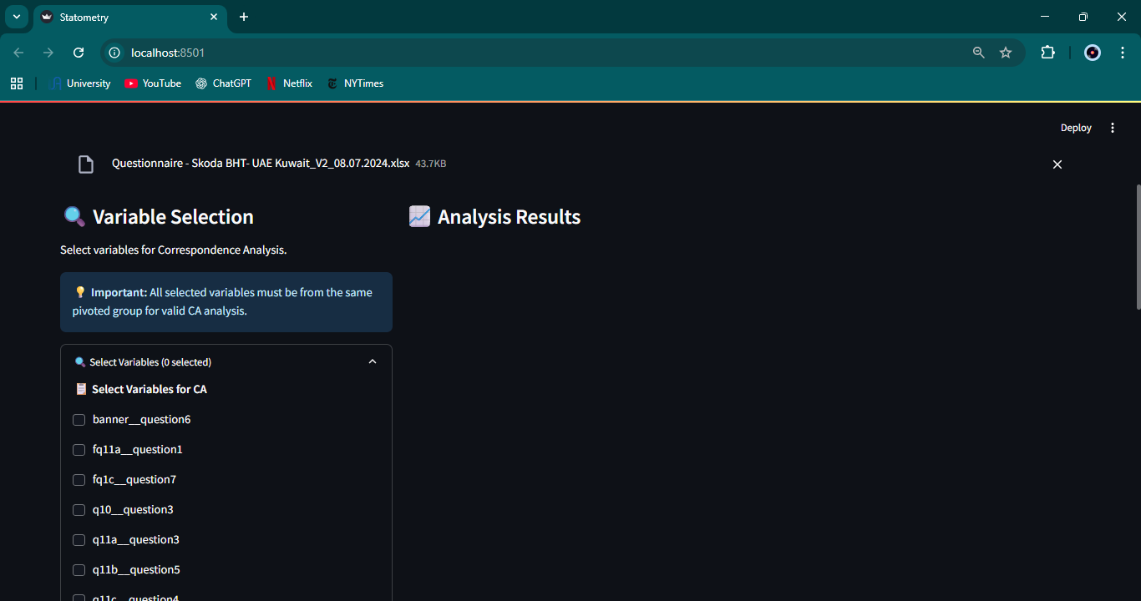
Figure A.12 – Streamlit screenshot (Screenshot 2025-11-30 180117.png)
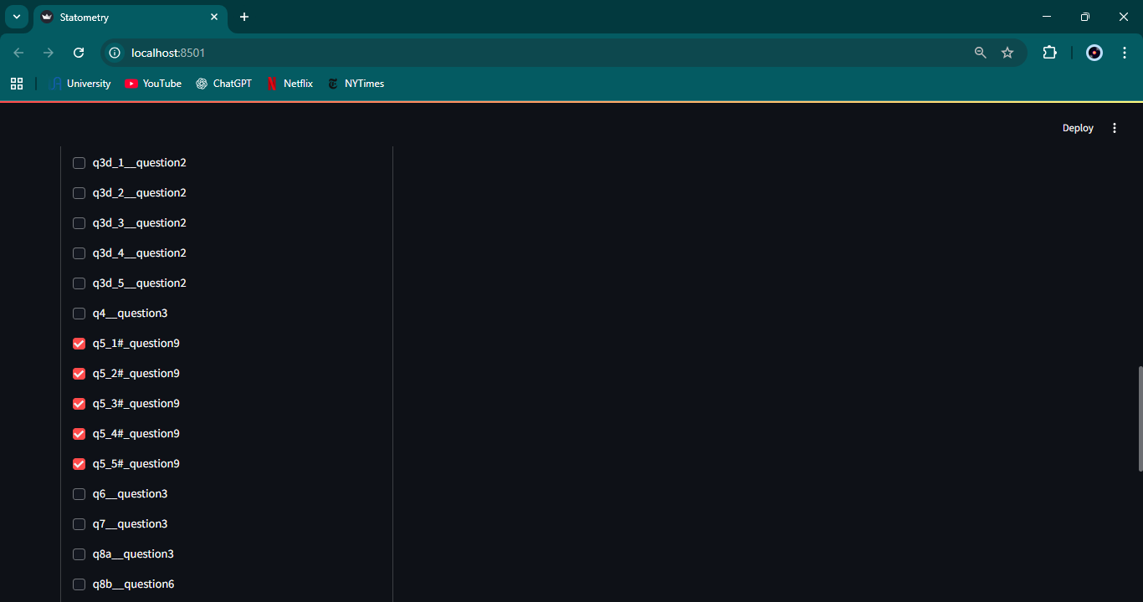
Figure A.13 – Streamlit screenshot (Screenshot 2025-11-30 180124.png)
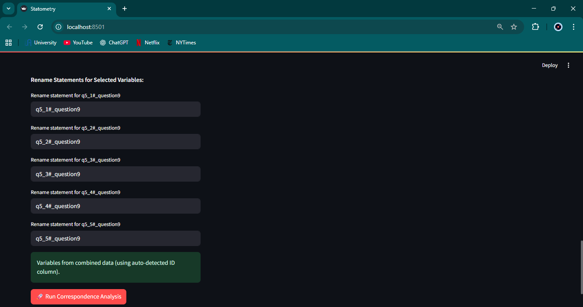
Figure A.14 – Streamlit screenshot (Screenshot 2025-11-30 180143.png)
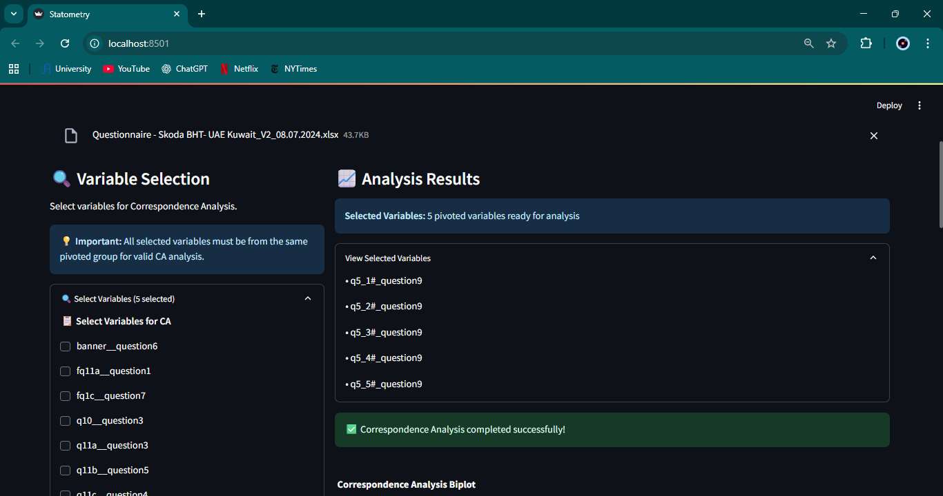
Figure A.15 – Streamlit screenshot (Screenshot 2025-11-30 180211.png)
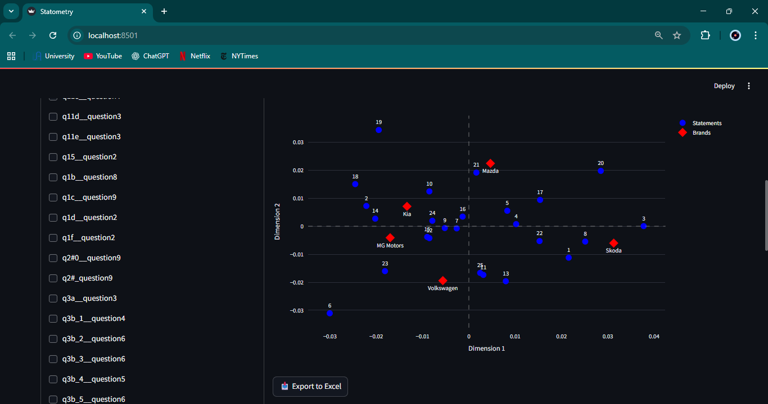
Figure A.16 – Streamlit screenshot (Screenshot 2025-11-30 180259.png)
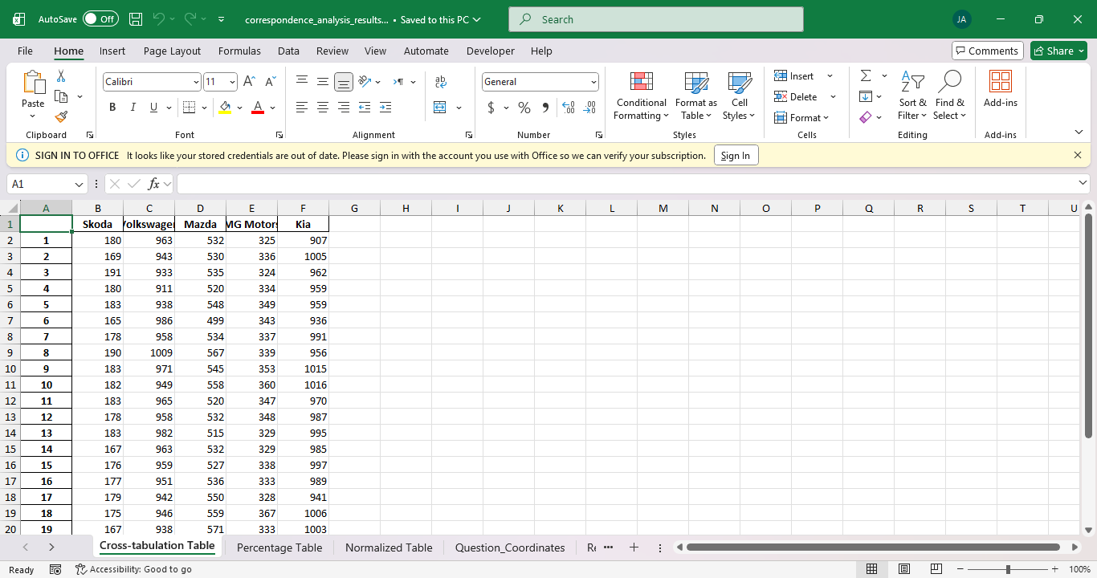
Figure A.17 – Streamlit screenshot (Screenshot 2025-11-30 180305.png)
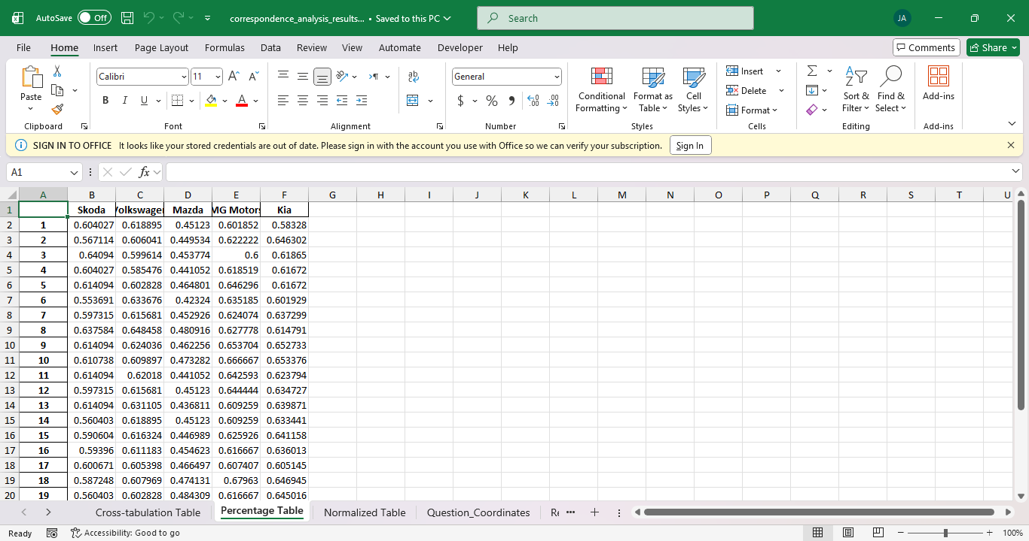
Figure A.18 – Streamlit screenshot (Screenshot 2025-11-30 180309.png)
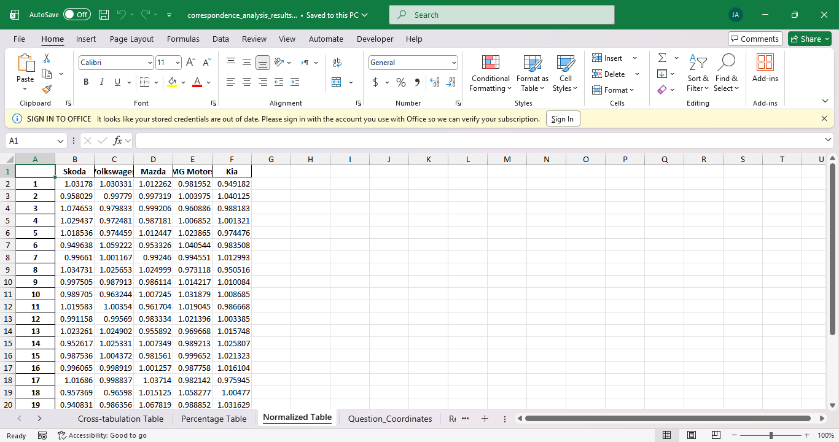
Figure A.19 – Streamlit screenshot (Screenshot 2025-11-30 180315.png)
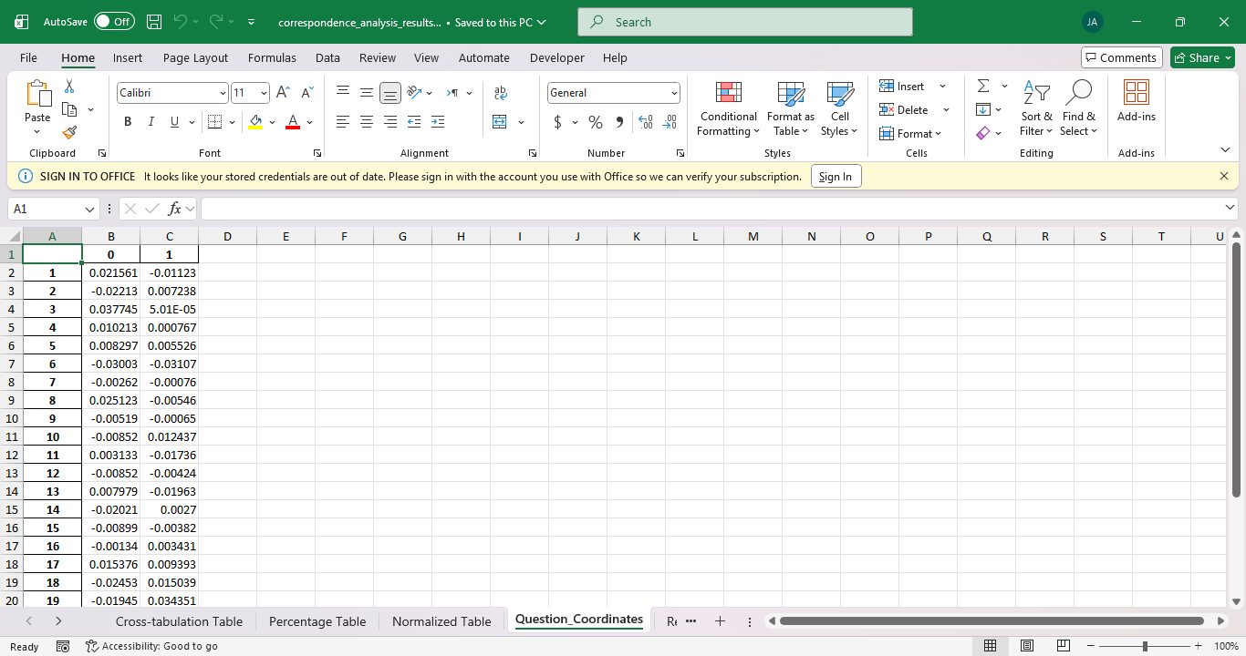
Figure A.20 – Streamlit screenshot (Screenshot 2025-11-30 180319.png)
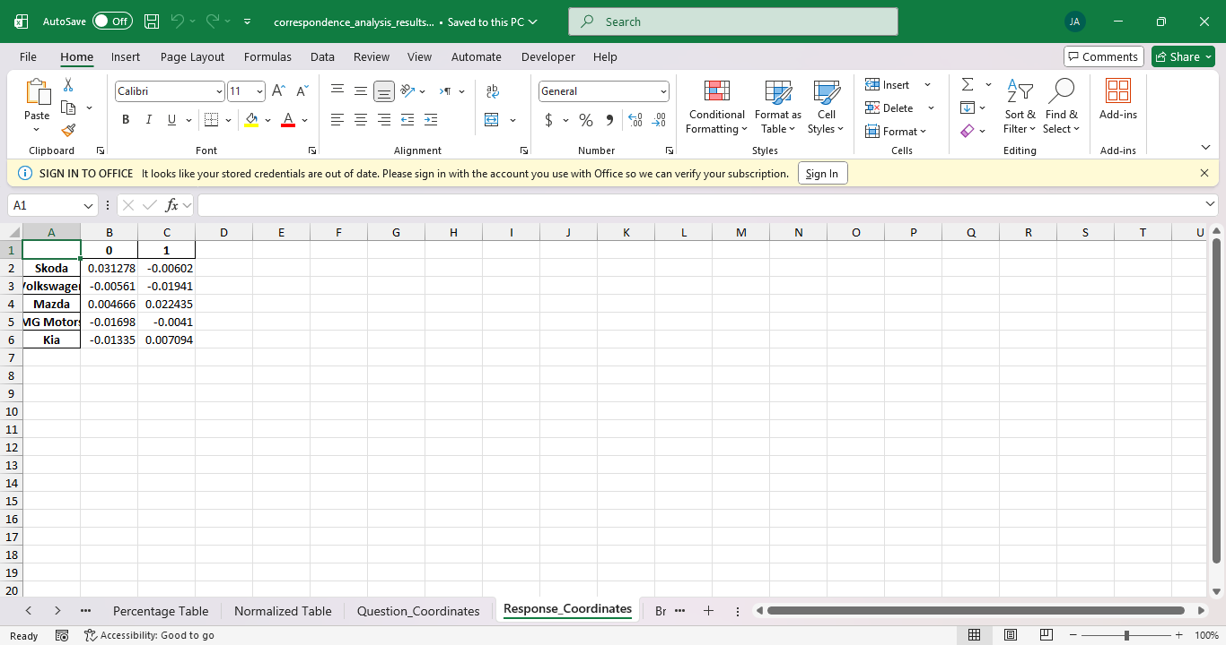
Figure A.21 – Streamlit screenshot (Screenshot 2025-11-30 180326.png)
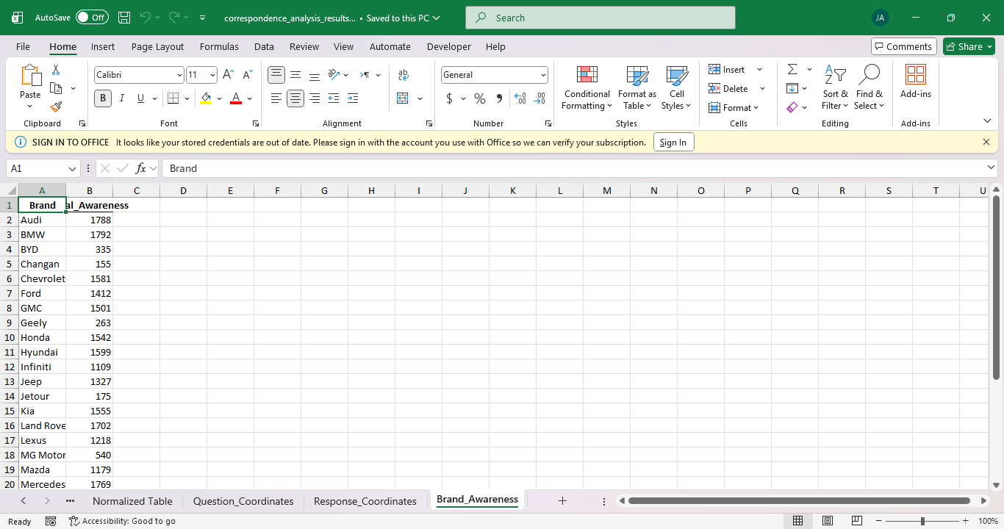

APPENDIX B – FLASK VERSION SCREENSHOTS
Figure B.1 – Flask screenshot (Screenshot 2025-11-30 180610.png)

Figure B.2 – Flask screenshot (Screenshot 2025-11-30 180615.png)

Figure B.3 – Flask screenshot (Screenshot 2025-11-30 180624.png)

Figure B.4 – Flask screenshot (Screenshot 2025-11-30 180628.png)

Figure B.5 – Flask screenshot (Screenshot 2025-11-30 180651.png)
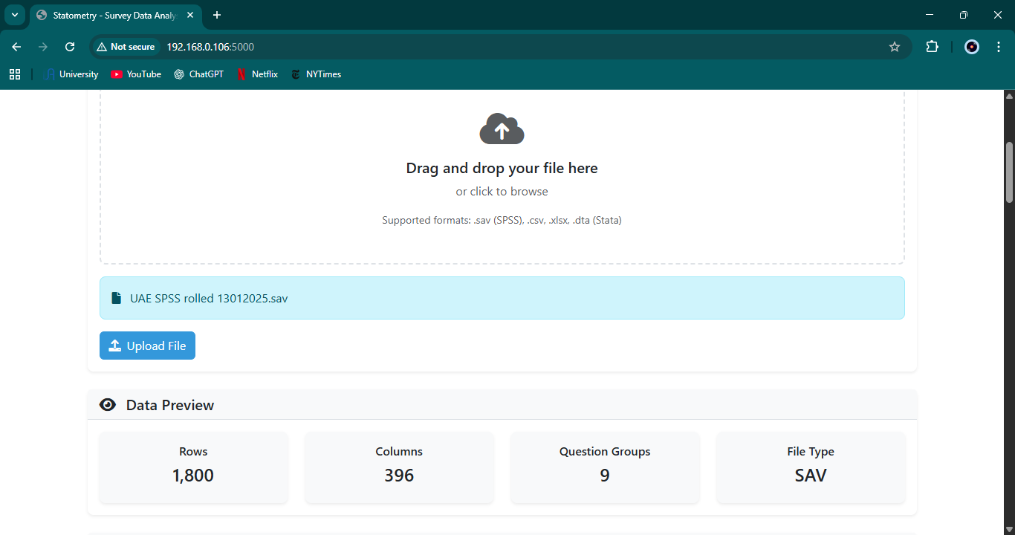
Figure B.6 – Flask screenshot (Screenshot 2025-11-30 180706.png)
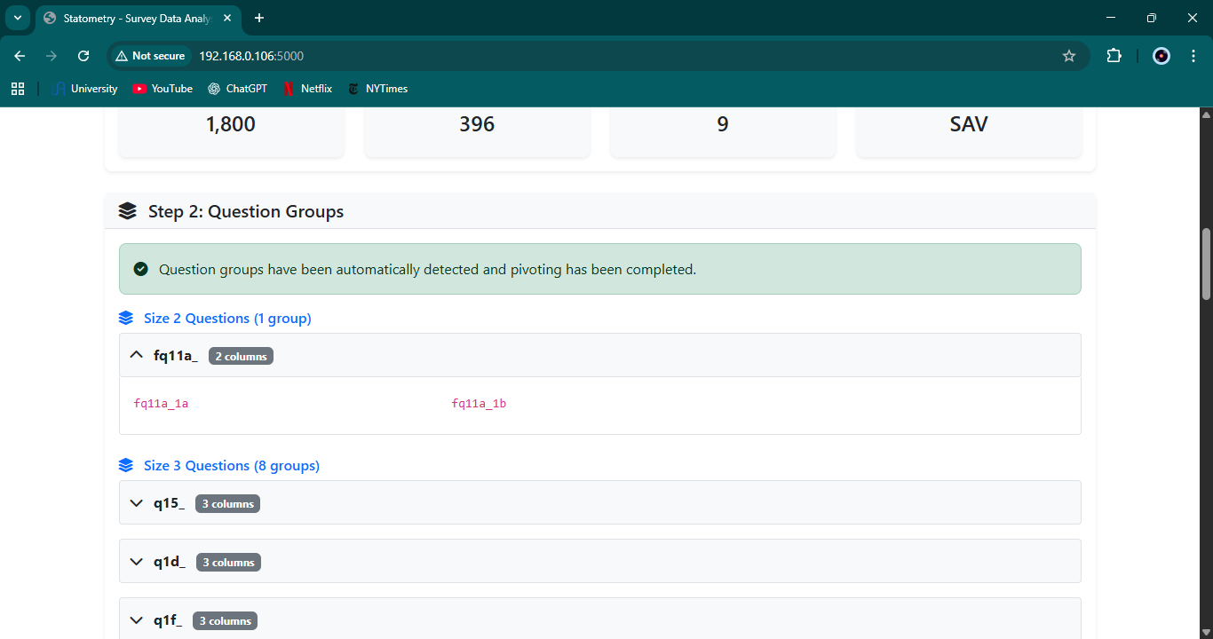
Figure B.7 – Flask screenshot (Screenshot 2025-11-30 180718.png)
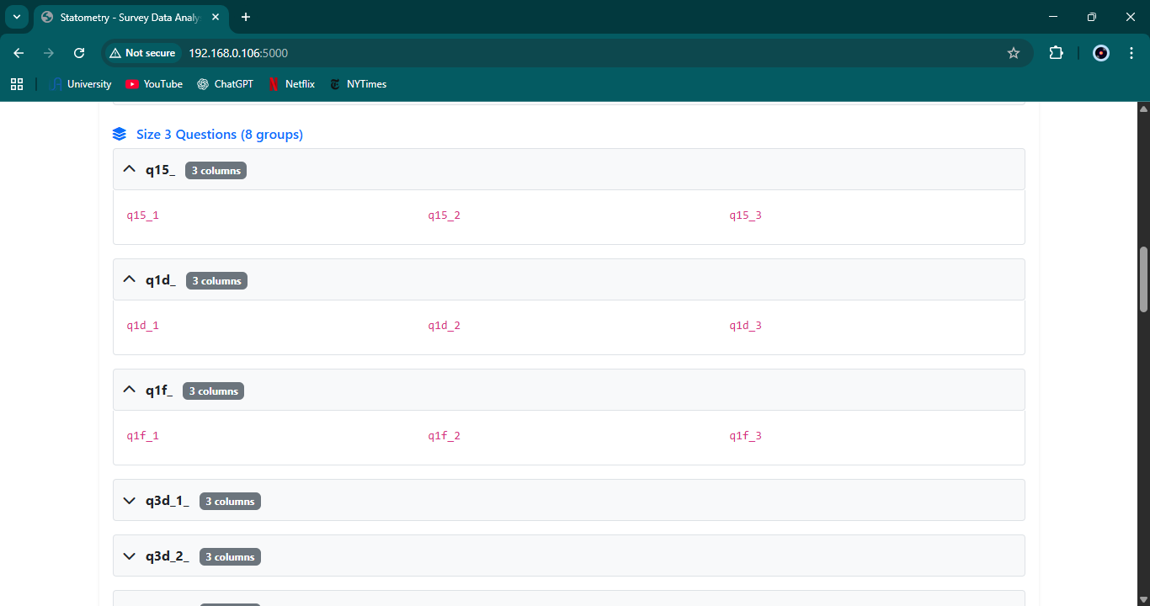
Figure B.8 – Flask screenshot (Screenshot 2025-11-30 180725.png)
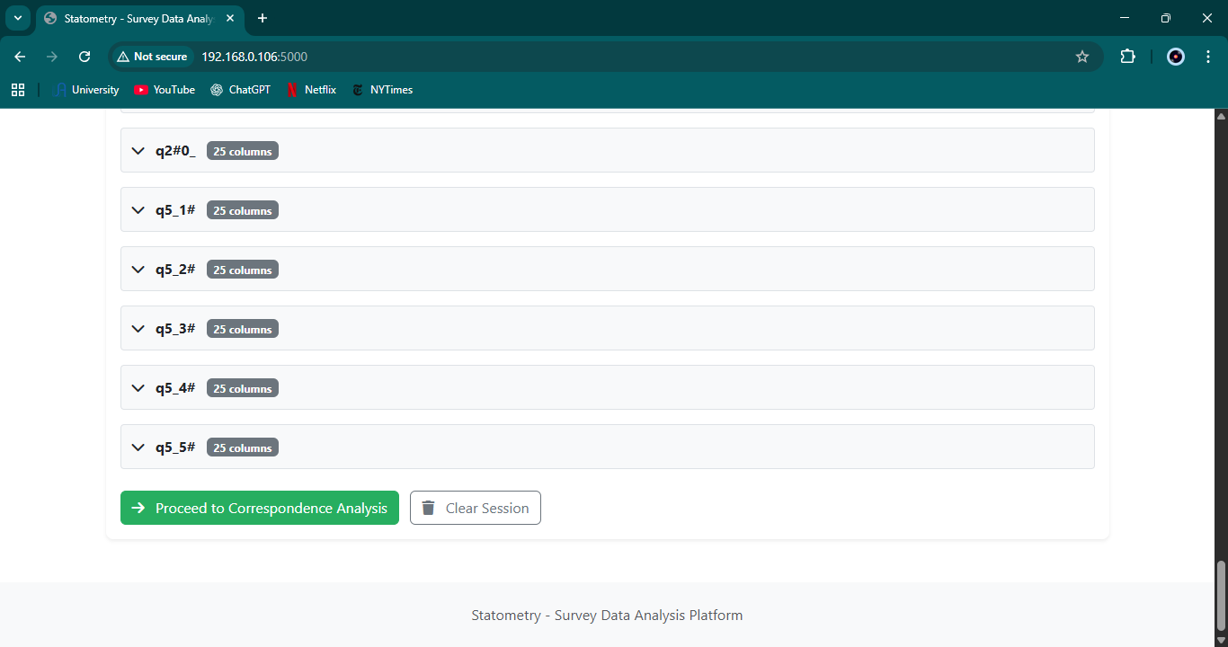
Figure B.9 – Flask screenshot (Screenshot 2025-11-30 180750.png)
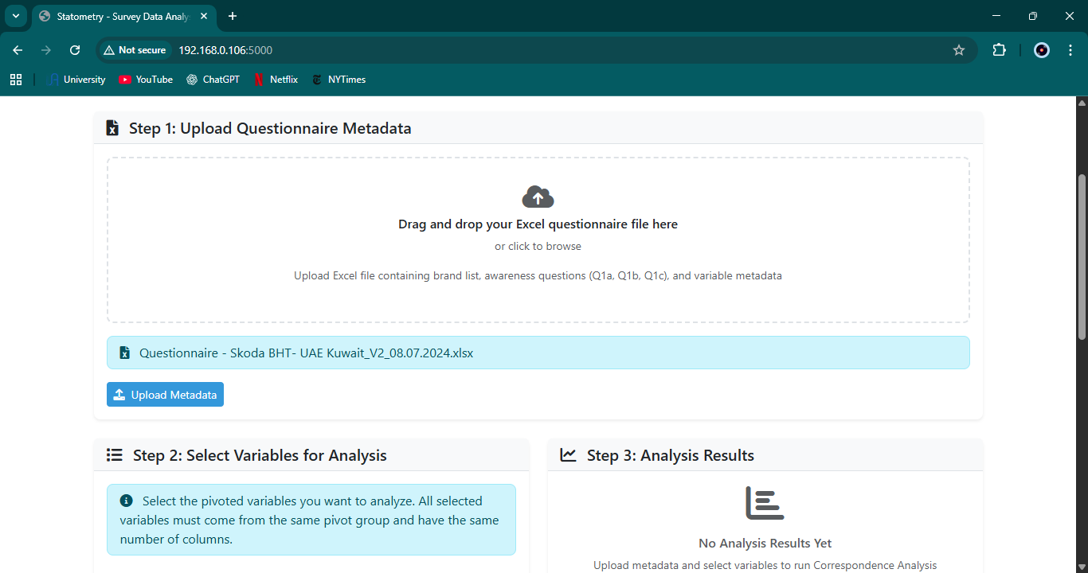
Figure B.10 – Flask screenshot (Screenshot 2025-11-30 180755.png)
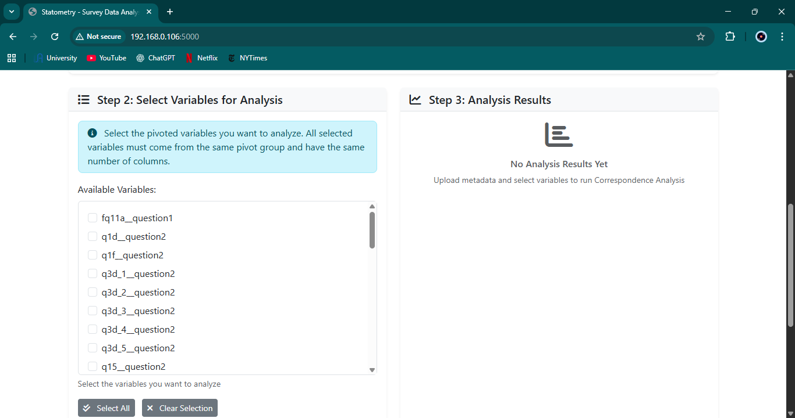
Figure B.11 – Flask screenshot (Screenshot 2025-11-30 180820.png)
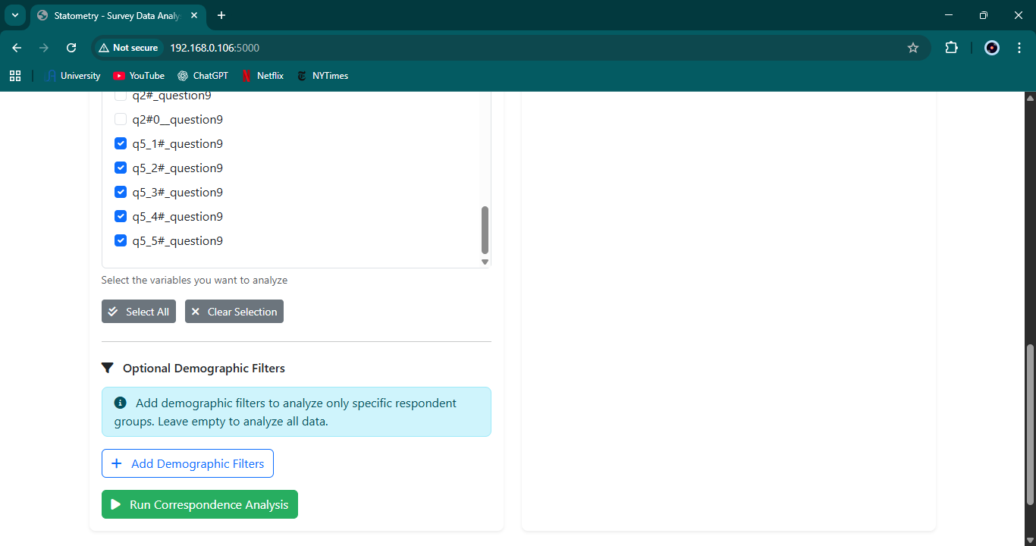
Figure B.12 – Flask screenshot (Screenshot 2025-11-30 180859.png)
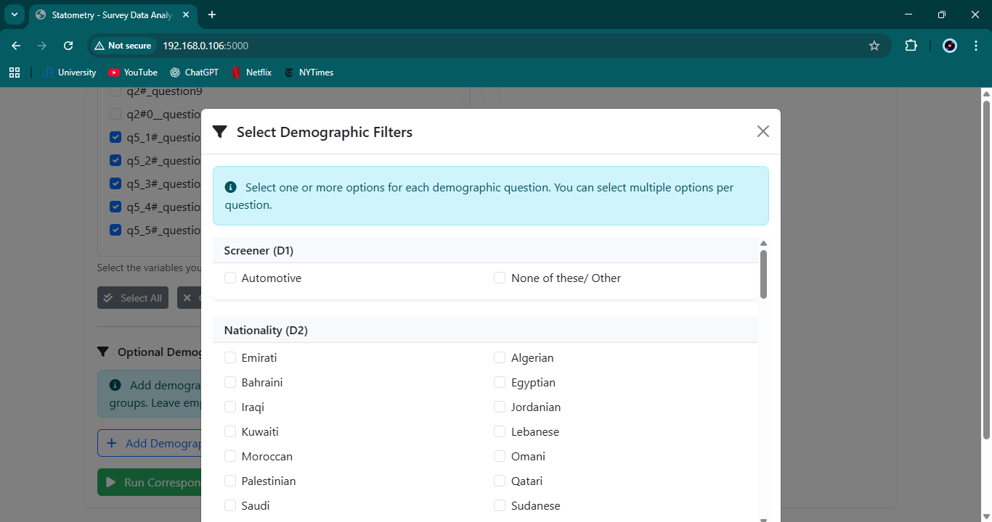
Figure B.13 – Flask screenshot (Screenshot 2025-11-30 180927.png)
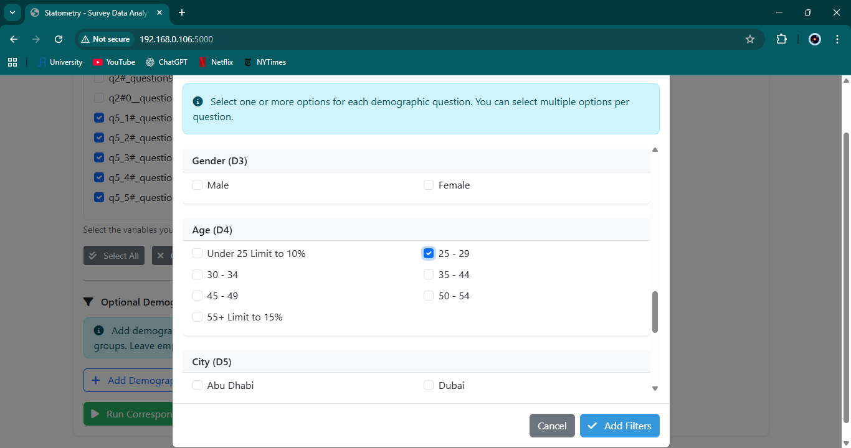
Figure B.14 – Flask screenshot (Screenshot 2025-11-30 180933.png)
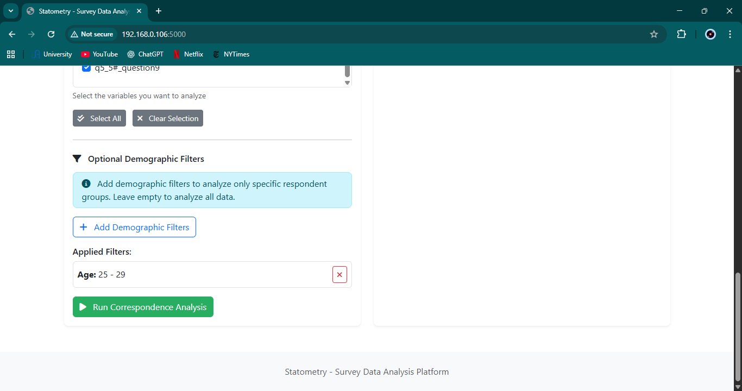
Figure B.15 – Flask screenshot (Screenshot 2025-11-30 180945.png)
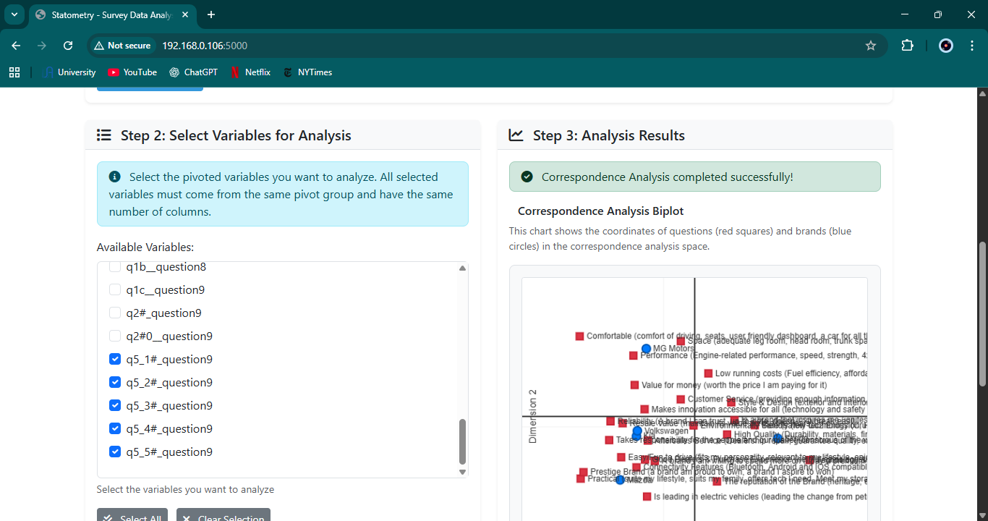
Figure B.16 – Flask screenshot (Screenshot 2025-11-30 180952.png)
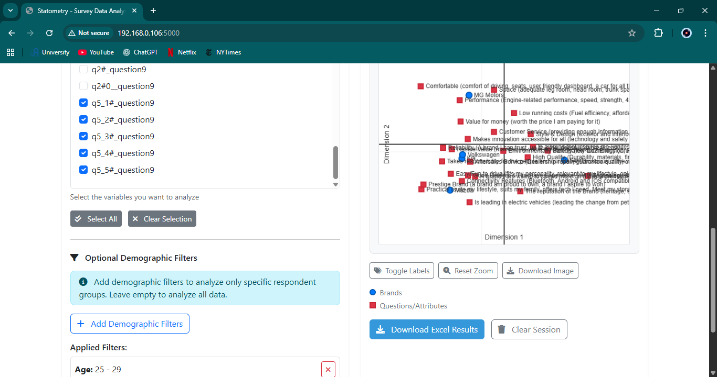
Figure B.17 – Flask screenshot (Screenshot 2025-11-30 181048.png)
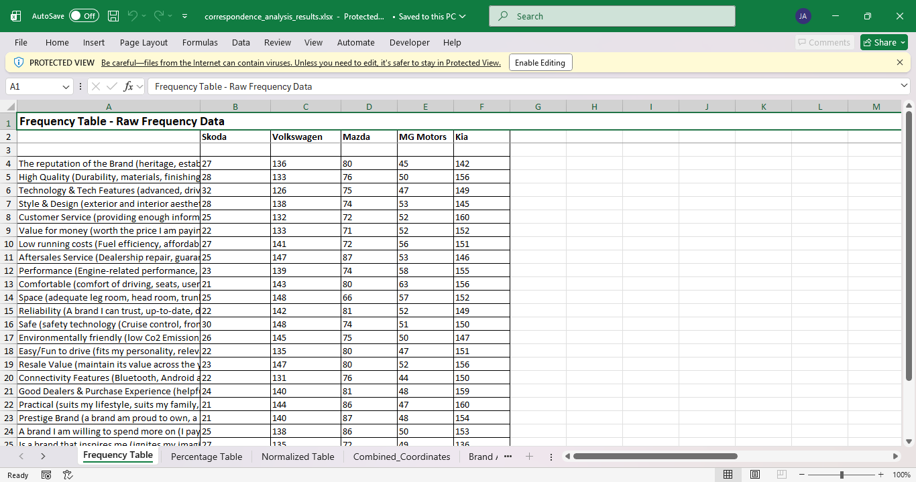
Figure B.18 – Flask screenshot (Screenshot 2025-11-30 181053.png)
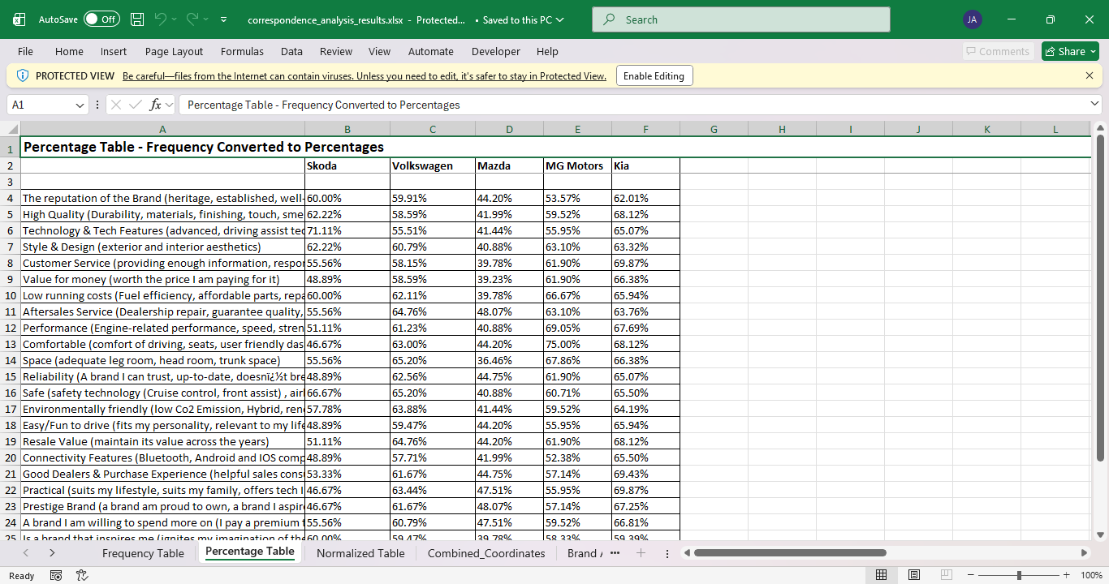
Figure B.19 – Flask screenshot (Screenshot 2025-11-30 181057.png)
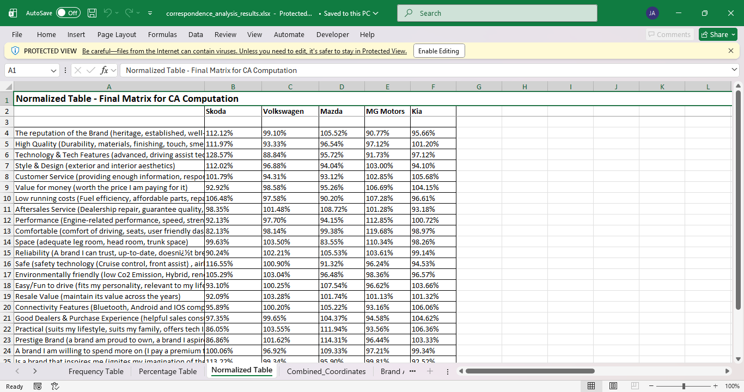
Figure B.20 – Flask screenshot (Screenshot 2025-11-30 181102.png)
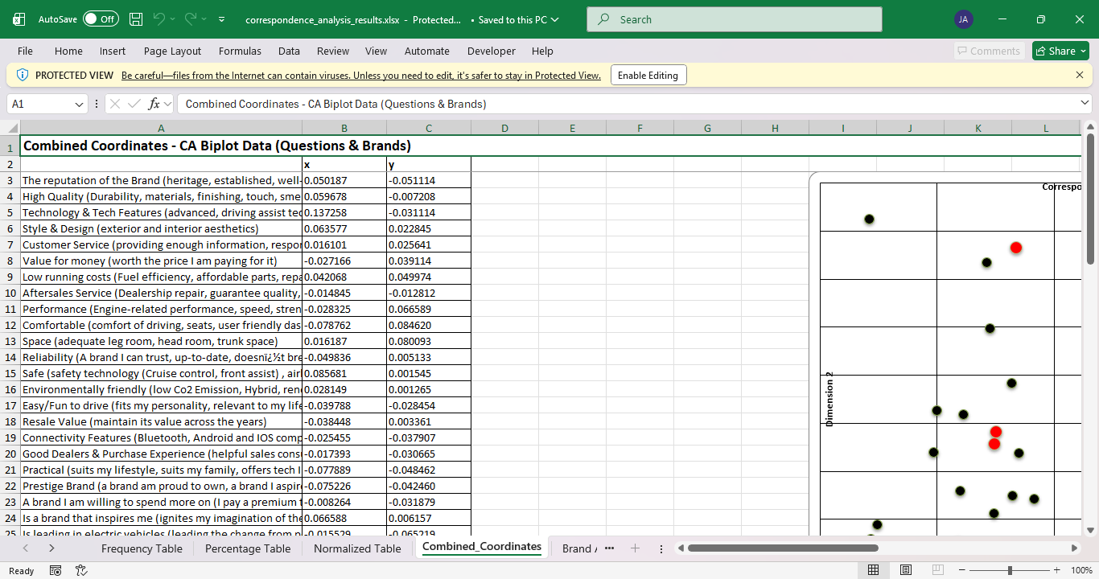
Figure B.21 – Flask screenshot (Screenshot 2025-11-30 181112.png)
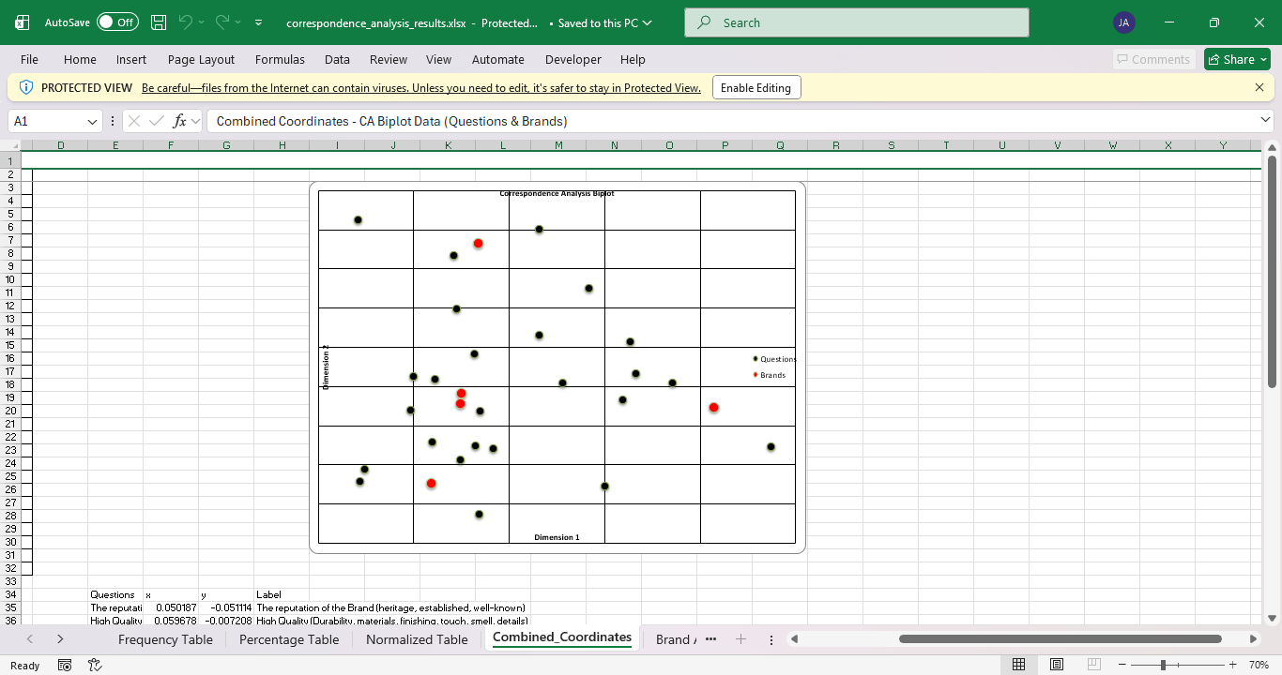
Figure B.22 – Flask screenshot (Screenshot 2025-11-30 181117.png)
